**Dabasiya Loaders**

Bhuj-Nakhatrana highway road,

Behind Shreeji Motor Garage,

Village: Mankuva, City: Bhuj-Kachh

(Gujarat-India)- 370030

Mob. 99090 71615

[www.dabasiyaloaders.com](http://www.dabasiyaloaders.com)

Email: dabasiyaloaders@gmail.com

DABASIYA LOADERS



***Quotation of***

***FRONT END LOADER***

***for***

***ARJUN NOVO***

***7th July, 2018***

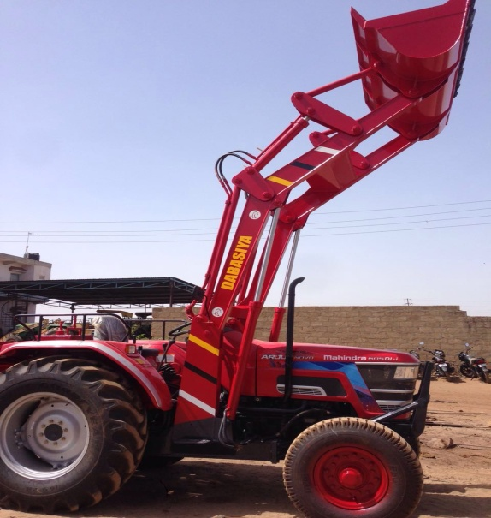

## TABLE OF CONTENTS

TABLE OF CONTENTS 2

ABOUT US 3

FRONT END LOADER SPECIFICATION 5

VARIETIES OF BUCKETS WITH PRICE 6

## ABOUT US

This document defines the Dabasiya Loaders proposal of Front End Loader suitable for Mahindra tractor Arjun Novo 57Hp, model 605.

The proposal includes:

**Introduction**

Dabasiya Loaders has been in business of manufacturing **hydraulic loaders & agricultural equipments** for the past 25 years, at Mankuva, Bhuj-Kutch, Gujarat.

We are a partnership firm engaged in manufacturing, exporting and supplying wide range of material handling equipment. We provide tractor attachments that can be fitted on various make of tractors such as Mahindra, John Deere, New Holland, Sonalika, preet, etc ranging from 35 HP to 90 HP.

Quality being one of the fundamental elements of our company has helped us to deliver excellent tractor attachments to our wide clientele and that’s why in a short span, we touched the heart of every customer by quality of our product & our services. We are continuously upgrading our expertise and production techniques to delivers world class product demanded by our wide range of clientele. We understand the significance of individuality thus consider customization critical to success of our business and equally important; satisfaction of our customers.

**Our Strengths Lies in:**

* Operational efficiency.
* Touched the heart of every customer by our product quality & services.
* Enduring customer relationships.
* Domain expertise and in depth technical knowledge of our team.
* Loyal employees.

We have nation-wide sales and service network and having good exposure in Exports.

**Exporting to the markets of:**

Kenya, Uganda, Tanzania, Congo, South Africa, Senegal, Ghana, Ethiopia, Australia, etc.

**Our equipment has been appreciated all over India owing to the following salient features:**

* Rugged design
* Superior performance
* Less maintenance cost
  + No need to change hydraulic oil up to 5 year or 15000 hour.
* Increase productivity
* Long service life

**Application Areas/ Industries**

We have been successful in offering tractor loader to various industries such as:

* Construction industry
* Agriculture industry
* Sugar industry
* Cement plants
* Paper mills
* Mining industry
* Wooden industry
* Coal industry
* Cotton industry

**Our prestigious customers**

Our valuable customers include:

* AshapuraMinechem Ltd.
* AshapuraPerfoclay Ltd.
* Jindal Saw Ltd.
* Parishi Construction
* Ruchi Soya Industry
* Shreeji Ginning
* Rainbow Paper Mill etc.

## FRONT END LOADER SPECIFICATION

## Dabasiya Loaders Preet 2 - Copy.jpgVARIETIES OF BUCKETS WITH PRICE

We expertise in making following type of buckets as tractor attachment:

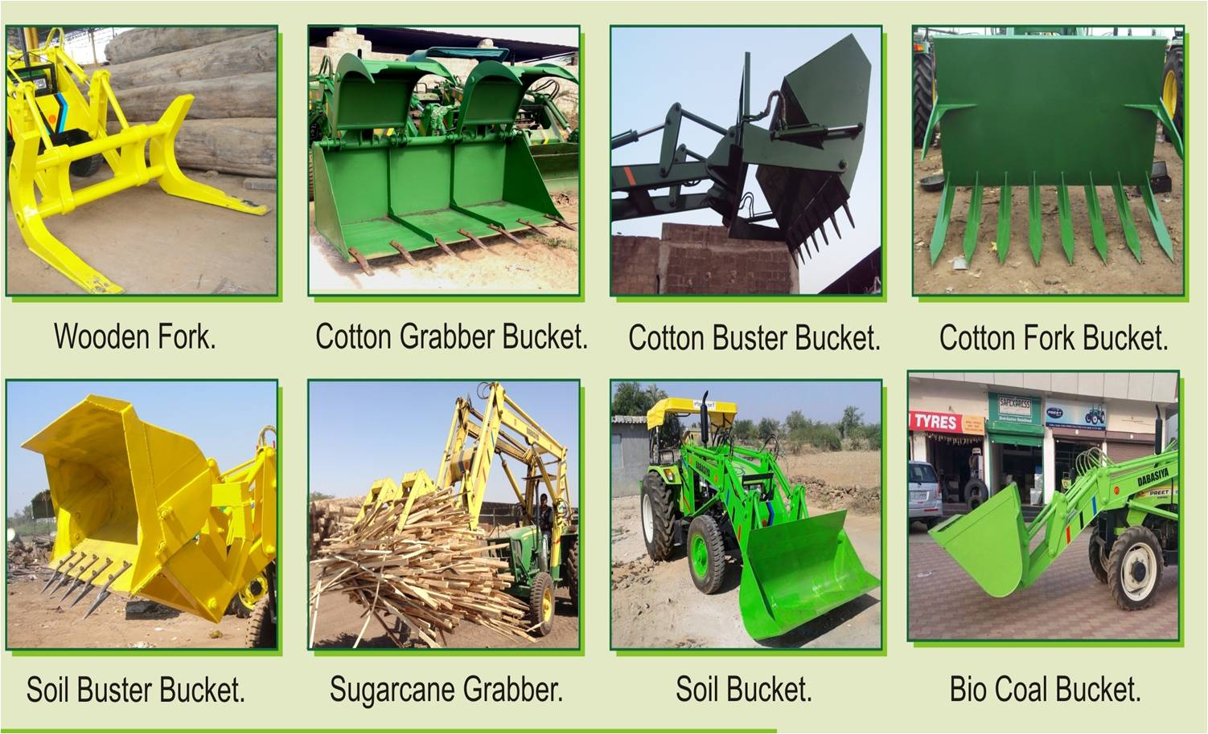

1. **WOODEN FORK BUCKET**

***Front end loader attachment on tractor with Wooden Fork Bucket***.

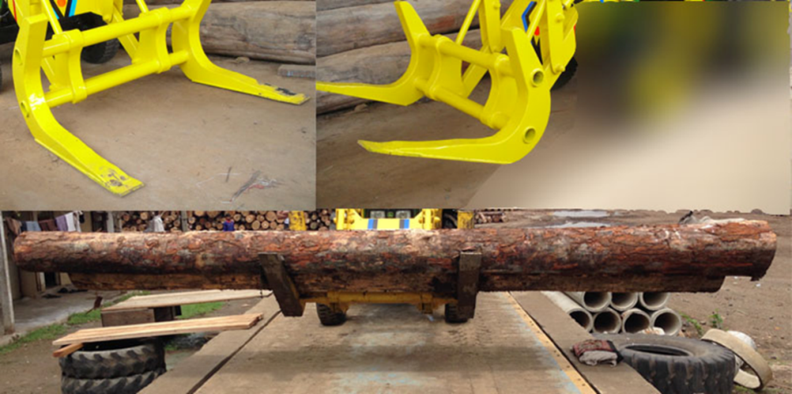Specification as per DL standard.

* **Product Code**: Wooden fork DBS-DL-S-13F.

Only DL standard is available.

Capacity of 1 Ton.

Pin height: 13 feet.

Hydraulic Oil is included in price.

**EX-Work Price: 2, 60,000 + GST 18%.**

**On site fitting: 2, 60,000 + 20,000 fitting charge + GST 18% + Transportation.**

**Dealer price: 2, 75,000 + GST 18%.**

**On site fitting: 2, 75,000 + 20,000 fitting charge + GST 18% + Transportation.**

**Customer price: 2, 85,000 + GST 18%.**

**On site fitting: 2, 85,000 + 20,000 fitting charge + GST 18% + Transportation.**

1. **COTTON GRABBER BUCKET**

***Front end loader attachment on tractor with Cotton Grabber Bucket and Paper Grabber Bucket***.

1. Specification as per DL high dumps.

* 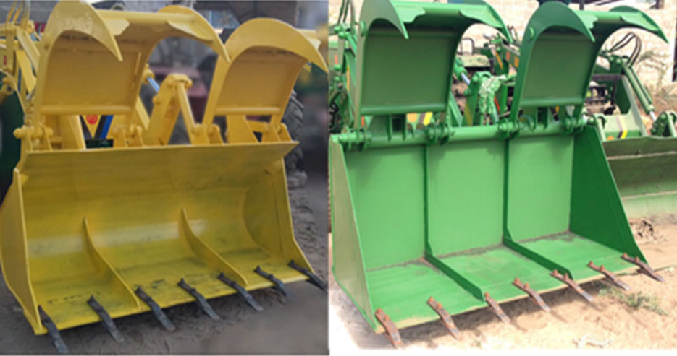**Product Code:** Cotton grabber DBS-DL-HD-14F square/round.

Capacity of 1 Ton.

Pin height 14 Feet.

**EX-Work Price: 3, 05,000 + GST 18%.**

**On site fitting: 3, 05,000 + 20,000 fitting charge + GST 18% + Transportation.**

**Dealer Price: 3, 20,000 + GST 18%.**

**On site fitting: 3, 20,000 + 20,000 fitting charge + GST 18% + Transportation.**

**Customer Price: 3, 30,000 + GST 18%.**

**On site fitting: 3, 30,000 + 20,000 fitting charge + GST 18% + Transportation.**

1. Specification as per DL standard.

* **Product Code:** Cotton grabber DBS-S-13F square/round.

Capacity of 1 Ton.

Pin height 13 Feet.

**EX-Work Price: 2, 95,000 + GST 18%.**

**On site fitting: 2, 95,000 + 20,000 fitting charge + GST 18% + Transportation.**

**Dealer Price: 3, 10,000 + GST 18%.**

**On site fitting: 3, 10,000 + 20,000 fitting charge + GST 18% + Transportation.**

**Customer Price: 3, 20,000 + GST 18%.**

**On site fitting: 3, 20,000 + 20,000 fitting charge + GST 18% + Transportation.**

1. **COTTON BUSTER BUCKET**

***Front end loader attachment on tractor with Cotton Buster Bucket***.

1. Specification as per DL standard.

* 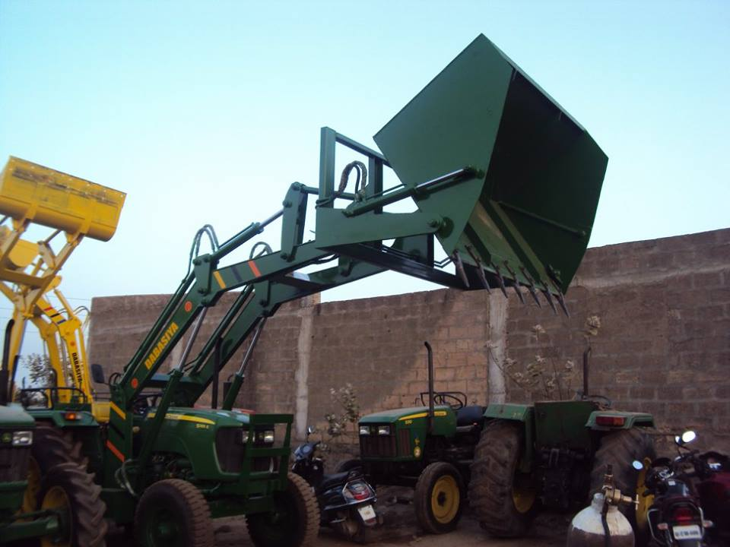**Product Code**: Cotton buster DBS-DL-S-13F square.

Capacity of 1 Ton.

Pin height 13feet.

Hydraulic Oil is included in price.

**EX-Work Price: 2, 95,000 + GST 18%.**

**On site fitting: 2, 95,000 + 20,000 fitting charge + GST 18% + Transportation.**

**Dealer Price: 3, 10,000 + GST 18%.**

**On site fitting: 3, 10,000 + 20,000 fitting charge + GST 18% + Transportation.**

**Customer Price: 3, 20,000 + GST 18%.**

**On site fitting: 3, 20,000 + 20,000 fitting charge + GST 18% + Transportation.**

1. Specification as per DL High Dump.

* **Product code:** Cotton buster DBS-DL-HD-14F square.

Capacity of 1 Ton.

Pin height: 14 feet.

Hydraulic Oil is included in price.

**EX-Work Price: 3, 05,000 + GST 18%.**

**On site fitting: 3, 05,000 + 20,000 fitting charge + GST 18% + Transportation.**

**Dealer Price: 3, 20,000 + GST 18%.**

**On site fitting: 3, 20,000 + 20,000 fitting charge + GST 18% + Transportation.**

**Customer Price: 3, 30,000 + GST 18%.**

**On site fitting: 3, 30,000 + 20,000 fitting charge + GST 18% + Transportation.**

1. **COTTON FORK BUCKET**

***Front end loader attachment on tractor with Cotton Fork Bucket***.

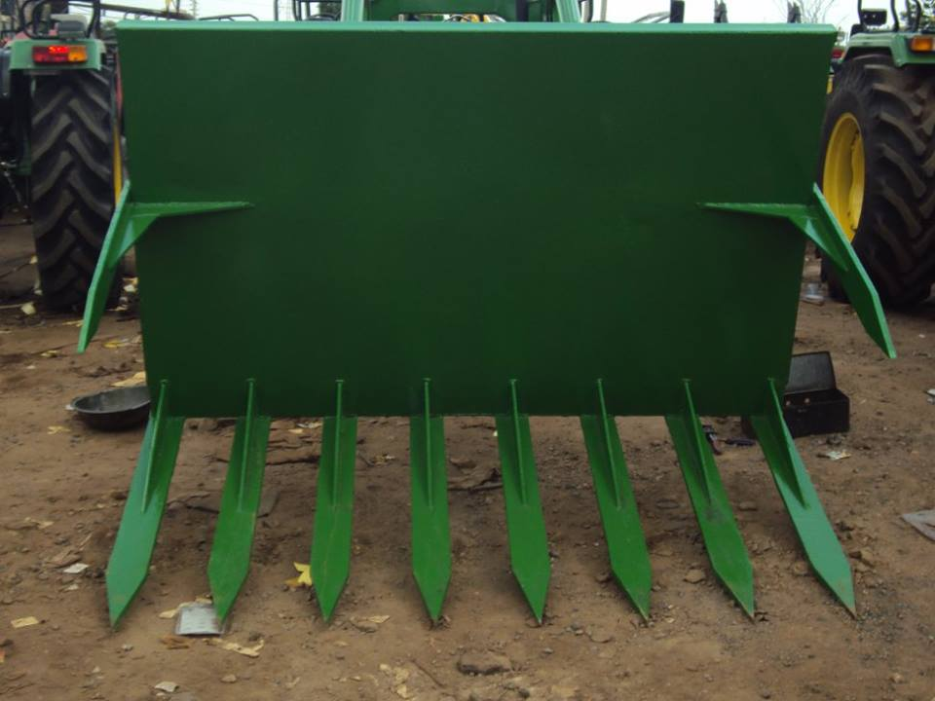Specification as per DL standard.

* **Product code:** Cotton fork DBS-DL-S-13F.

Only DL standard is available.

Capacity of 1 Ton.

Pin height: 13 feet.

Hydraulic Oil is included in price.

**EX-Work Price: 2, 60,000 + GST 18%.**

**On site fitting: 2, 60,000 + 20,000 fitting charge + GST 18% + Transportation.**

**Dealer Price: 2, 75,000 + GST 18%.**

**On site fitting: 2, 75,000 + 20,000 fitting charge + GST 18% + Transportation.**

**Customer Price: 2, 85,000 + GST 18%.**

**On site fitting: 2, 85,000 + 20,000 fitting charge + GST 18% + Transportation.**

1. **SOIL BUSTER BUCKET**

***Front end loader attachment on tractor with Soil Buster Bucket***.

Specification as per DL standard.

* 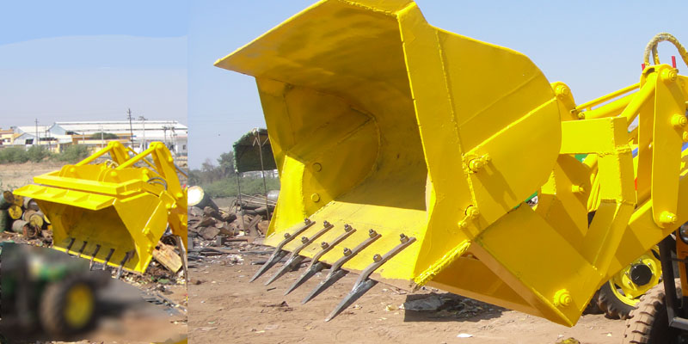**Product code:** Soil buster DBS-DL-S-13F.

Only DL standard is available.

Capacity of 1 Ton.

Pin height: 13 feet.

Hydraulic Oil is included in price.

**EX-Work Price: 2, 95,000 + GST 18%.**

**On site fitting: 2, 95,000 + 20,000 fitting charge + GST 18% + Transportation.**

**Dealer Price: 3, 10,000 + GST 18%.**

**On site fitting: 3, 10,000 + 20,000 fitting charge + GST 18% + Transportation.**

**Customer Price: 3, 20,000 + GST 18%.**

**On site fitting: 3, 20,000 + 20,000 fitting charge + GST 18% + Transportation.**

1. **SUGARCANE GRABBER BUCKET**

***Front end loader attachment on tractor with Sugarcane Grabber Bucket***.

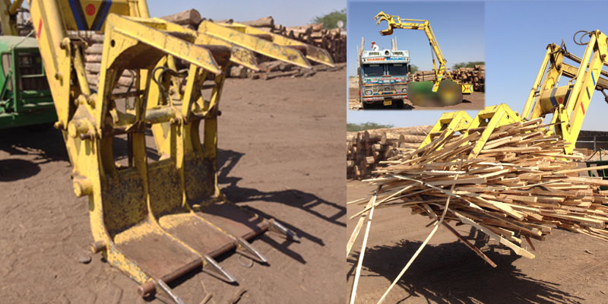**Product code:** Sugarcane grabber DBS-20F.

Capacity of 1 Ton.

Pin height: 20 feet.

Hydraulic Oil is included in price.

**EX-Work Price: 4, 00,000 + GST 18%.**

**Dealer Price: 4, 15,000 + GST 18%.**

**Customer Price: 4, 25,000 + GST 18%.**

**On site fitting is not possible.**

1. **SOIL BUCKET**

***Front end loader attachment on tractor with Soil Bucket***.

1. 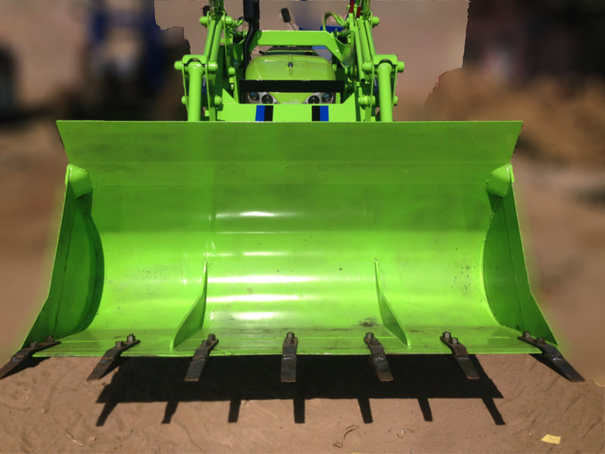Specification as per DL standard.

* **Product Code**: Soil standard DBS-DL-S-13F.

Capacity of 1 Ton.

Hydraulic Oil is included in price.

**EX-Work Price: 2, 60,000 + GST 18%.**

**On site fitting: 2, 60,000 + 20,000 fitting charge + GST 18% + Transportation.**

**Dealer Price: 2, 75,000 + GST 18%.**

**On site fitting: 2, 75,000 + 20,000 fitting charge + GST 18% + Transportation.**

**Customer Price: 2, 85,000 + GST 18%.**

**On site fitting: 2, 85,000 + 20,000 fitting charge + GST 18% + Transportation.**

1. Specification as per DL High Dump.

* **Product code:** Soil standard DBS-DL-HD-14F.

Capacity of 1 Ton.

Pin height 14 feet.

Hydraulic Oil is included in price.

**EX-Work Price: 2, 70,000 + GST 18%.**

**On site fitting: 2, 70,000 + 20,000 fitting charge + GST 18% + Transportation.**

**Dealer Price: 2, 85,000 + GST 18%.**

**On site fitting: 2, 85,000 + 20,000 fitting charge + GST 18% + Transportation.**

**Customer Price: 2, 95,000 + GST 18%.**

**On site fitting: 2, 95,000 + 20,000 fitting charge + GST 18% + Transportation.**

1. **BIO-COAL BUCKET**

***Front end loader attachment on tractor with Bio Coal and Husk Bucket***.

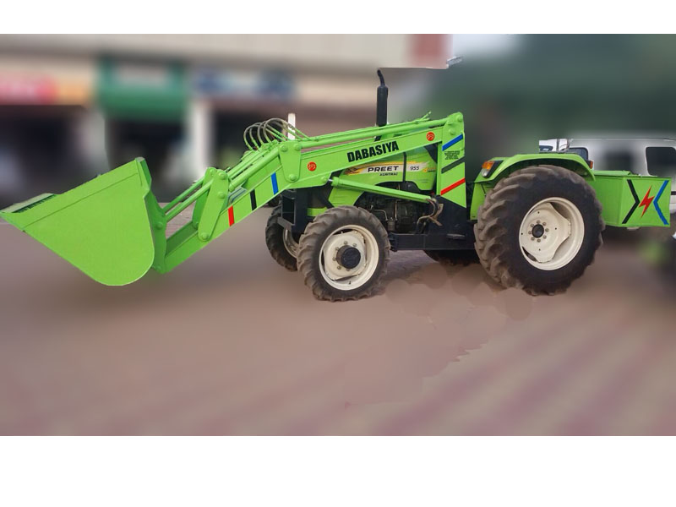

1. Specification as per DL standard.

**Product Code**: Bio coal DBS-DL-S-1.2cbm.

Only DL standard is available.

Bucket size: 1.2cbm.

Pin height: 13 feet.

Hydraulic Oil is included in price.

**EX-Work Price: 2, 75,000 + GST 18%.**

**On site fitting: 2, 75,000 + 20,000 fitting charge + GST 18% + Transportation.**

**Dealer Price: 2, 90,000 + GST 18%.**

**On site fitting: 2, 90,000 + 20,000 fitting charge + GST 18% + Transportation.**

**Customer Price: 3, 00,000 + GST 18%.**

**On site fitting: 3, 00,000 + 20,000 fitting charge + GST 18% + Transportation.**

**Terms & Conditions:**

* All prices are quoted based on the design that is proposed to Mahindra tractor Arjun Novo 605 model 57HP. Any further changes to the design or HP will be quoted separately.
* Additional taxes, duties and levies are extra at actual, as applicable.
* This quotation is valid for 30 days from date of submission.
* Shipping Terms: Ex Works DABASIYA LOADERS, Mankuva.
* Payment terms: 50% Advance along-with PO; remaining 50% at before delivery.
* Production lead time:

10-15days from purchase order.

